Below you will find a concise review of different financing sources Poland is eligible to within the upcoming 7 years. The compilation was prepared by our business partner - Crido Taxand Sp. z o. o., who we would like to thank very much for this excellent document.
OVERVIEW OF SUPPORT SOURCES FOR INVESTMENTS WITHIN THE NEW EU FINANCIAL FRAMEWORK 2014-2020

- DIVISION OF THE EUROPEAN FUNDS 2014-2020
Poland is the biggest EU funds beneficiary among all member states in the new 2014-2020 financial framework. The funds allocation for Poland amounts to EUR 82.5 billion. During the new EU financial framework it will be possible to get public aid for a wide range of activities, including: innovative investment projects, R&D projects, purchase of R&D infrastructure, revitalization as well as investments in environmental protection and renewable energy sources.
Please find below the most important information concerning EU funds in Poland.
REGIONAL PROGRAMMES
NATIONAL PROGRAMMES

Proposed division of EU Funds 2014-2020 between regions (EUR mln)
Infrastructure and environment (OP I&E)

EUR
27,5
bln

Eastern Poland (OP EP)
Digital Poland (OP DP)
Knowledge, Education & Development (OP KE&D)

Smart Development
(OP SD)
EUR
1 726,6

1 863,0

8,6
1 599,7
bln
1 212,4

1 901,7

2 087,9

EUR
4,4
906,1

2 447,9

bln
2 228,8

EUR
2 250,5

2 253,9

2,3
1 363,2

bln
944,1

2 112,2

3 473,6

EUR
2 875,5

2,1
bln
Total amount of funds under Regional Operational Programmes (ROP) - EUR 31 247,00 mln

In addition, projects in the field of agriculture will be able to receive support under the Rural Development Programme (RDP)
- SUPPORT AREAS

NEW INVESTMENTS
Types of projects | Implementation of R&D results, implementation of innovative production technologies / products, expansion of businesses
Support programmes | OP SD, ROP
Type of support | Financial instruments / grants

RESEARCH & DEVELOPMENT
Types of projects | Research and development works, Research Data Centers (RDC) creation/development, development of R&D infrastructure
Support programmes | OP SD, ROP, OP EP, national programmes (The National Centre for Research and Development)
Type of support | Financial instruments / grants

ENVIRONMENTAL PROJECTS
Types of projects | Waste management and rational use of water
Support programmes | OP I&E, ROP, national programmes (The National Fund of Environmental Protection and Water Management)
Type of support | Financial instruments / grants

ENERGY SECTOR / ENERGY EFFICIENCY
Types of projects | Renewable energy sources, construction/expansion of wind farms, biomass and biogas plants, application of energy efficient technologies in enterprises, modernization and expansion of production lines into more energy efficient ones
Support programmes | OP I&E, ROP, national programmes (The National Fund of Environmental Protection and Water Management)
Type of support | Financial instruments / grants

INFRASTRUCTURE
Types of projects | Preparation of investment areas, modernization/expansion of existing infrastructure (e.g. railway infrastructure, port infrastructure)
Support programmes | OP I&E, ROP
Type of support | Financial instruments / grants

REVITALISATION
Types of projects | Degraded land restoration, monuments protection, public spaces development
Support programmes | ROP
Type of support | Financial instruments / grants

TOURISM
Types of projects | Investment activities development in the area of ​​tourism, construction of tourist infrastructure
Support programmes | ROP
Type of support | Financial instruments / grants

HEALTH CARE
Types of projects | Purchase of equipment and medical devices, construction / renovation of health care infrastructure
Support programmes | OP I&E, ROP
Type of support | Financial instruments / grants

RURAL DEVELOPMENT
Types of projects | Purchase of machinery or equipment for product processing, storage or preparation to sale, construction / modernization of production buildings or magazines
Support programmes | RDP
Type of support | Grants

HUMAN CAPITAL
Types of projects | Employees training, development of new curricula, training, practice, internships and career counseling
Support programmes | OP KE&D
Type of support | Financial instruments / grants

- SUPPORT INTENSITY *

- Support limits for investment projects:
Maximum intensity for investment projects.
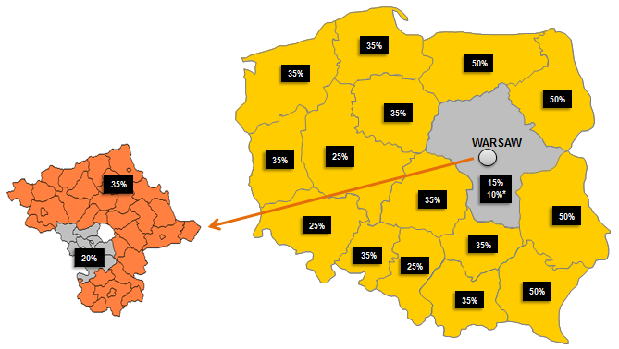
Micro and small enterprises +20%
Medium-sized enterprises +10%
*lower level aid intensity from 01.2018
- Support limits for other projects:
R&D: up to 80%
Environment: up to 70%
Energy efficiency: up to 65%
Infrastructure: up to 70%
Revitalization: up to 70%
Tourism: up to 70%
Health care: up to 70%
Rural development: up to 85%
Human capital: up to 70%
*Final level of aid intensity will be possible to determine after recognition of the project specifics

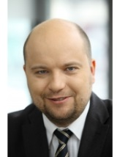
- CONTACT
Michał Gwizda
Partner
michal.gwizda@taxand.pl
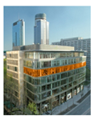

Wojciech Kwiatkowski
Manager
wojciech.kwiatkowski@taxand.pl

Address
Ul. Grzybowska 5A
(Grzybowska Park)
00-132 Warszawa
www.taxand.pl

